Model SVL-4020SX-F

High Precision Linear Guide Way Compact Vertical Machining Center

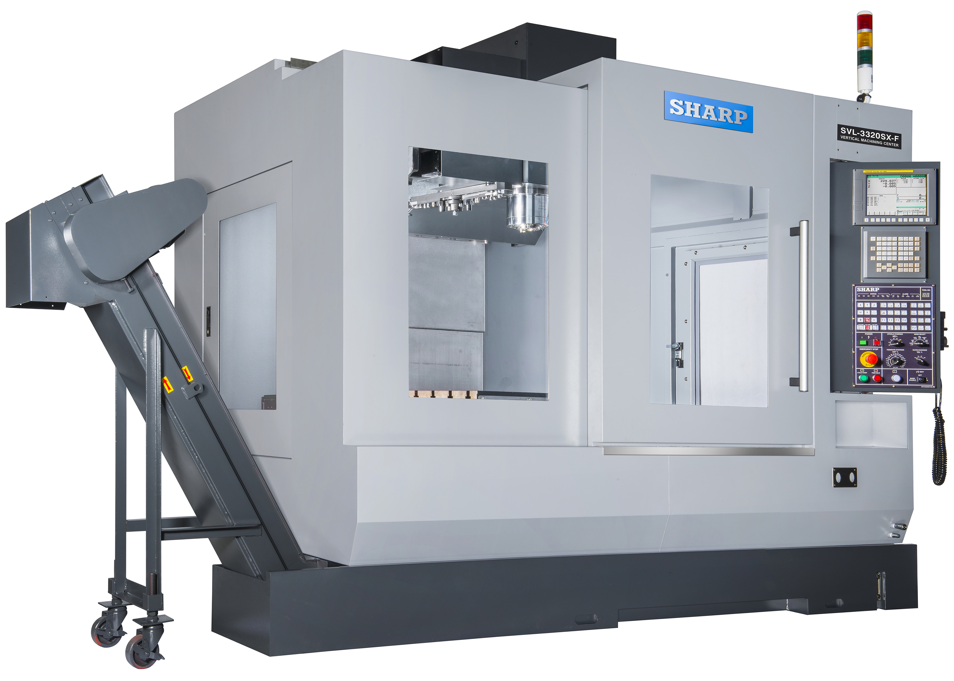

Photo show as SVL 3320 SX with optional flat belt chip conveyor

SVL-4020SX-F Main Features

Linear Guide Way Construction  Machine Travels: X = 40.2” , Y = 20.1” , Z = 22”  Worktable: 47.2” x 19.7”  CNC Control:  Fanuc 0i-MD  - 8.4” color LCD  - Remote jog handle (MPG)  - USB port, RS232 interface  - 512K memory, 40 blocks look ahead  - Manual Guide oi  - Embedded Ethernet  - 4 spare M codes  - 2 year warranty parts and labor  Spindle:  - Big plus CAT-40 taper  - 12,000 rpm  - Rigid tapping  - Spindle chiller  - Air blow (for cutting dry) | Automatic Tool Changer:  - 30 tools, Arm type  - Air blast at tool change  Rapid Traverse : 1,417 in/min  Coolant System:  - 63 gallon roll out coolant tank  - Flood coolant system  Coolant Through Spindle up to 1000 PSI prepped, optional item  Spindle Oil Chiller  Heat Exchange System for Electric Cabinet  Machine Construction:  - All Meehanite cast iron structural components  - Liner Guide Way construction  - Precision hand scraping on all structural components  - Double anchored, pre-tensioned double nut ball screws  - Full metal enclosure with removable side doors  - Full metal way covers  Footprint :  - W: 114.2” / D:84.6” / H: 101.2”

Standard Machine Specifications
- Specifications |  | SVL-4020SX-F  Fanuc Oi-MD
- Work Capacity
- X axis travel | mm (inch) | 1020( 40.2” )
- Y axis travel | mm (inch) | 510 ( 20.1” )
- Z axis travel | mm (inch) | 560 (22” )
- Spindle nose to table | mm (inch) | 150 - 710 ( 5.9” – 28” )
- Spindle center to column | mm (inch) | 608 (23.9 )
- Worktable
- Table area | mm (inch) | 1200 x 500 (47.2” x 19.7” )
- Max. work piece weight | kg (lb.) | 500 (1100 lbs.)
- T-Slot (Number x Width x pitch ) |  | 5 x 18 x 100 ( 5 x 0.7” x 3.9” )
- Spindle
- Spindle taper |  | Big plus CAT-40
- Spindle speed | rpm | 12,000
- Spindle motor: cont. / 30 min | kw (hp) | 11/15 (15/20)
- Transmission |  | Belt drive
- Automatic Tool Changer
- ATC type |  | Arm type
- Tool capacity |  | 30
- Max. tool diameter | mm (inch) | 80 (3.1” )
- Without adjacent tool | mm (inch) | 125 ( 4.9 “)
- Max. tool length | mm (inch) | 300 (11.8” )
- Max. tool weight | kg (lb.) | 7 (15.4 lbs)
- Tool change time (tool to tool) |  | 5.4 sec
- Tool change time (chip to chip) |  | 7 sec
- Method of tool selection |  | Random
- Motion
- Rapid traverse | mm/min (ipm) | X / Y / Z 36,000 ( 787.4 ipm )
- Cutting feed rate | mm/min (ipm) | 1 - 10,000 ( 0.04 – 393.7 ipm )
- Transmission |  | Direct drive
- Positioning accuracy* | mm (inch) | +/- 0.004 ( 0.0002” )
- Repeatability accuracy* | mm (inch) | +/- 0.003 ( 0.0001” )
- Linear guide width, X/Y/Z | mm( inch) | 30/35/35( 1.2”x1.4’x1.4”)
- Ball screw diameter, X/Y/Z | mm(inch) | 40 ( 1.57”)

- Specifications |  | SV-4020SX-F  Fanuc Oi-MD
- Coolant System
- Coolant tank capacity | L (gal) | 240 (63)
- Number of Coolant Nozzles |  | 6
- Machine Size
- Floor space (w/o chip conveyor) | mm (inch) | W: 2900 (114” ) x D: 2150 (84.6” )
- Height** | mm (inch) | 2570 ( 101.2” )
- Weight | kg (lb.) | 5500 ( 12,100 lbs.)
- Door opening | mm (inch) | 1300 ( 51.2” )
- Power Requirements
- Electrical | 60 Hz | 220 V / 3 Phase / 20 KVA
- Air |  | 6 CFM @ 88 psi
* Proper foundation and environmental controls are required
** Overall height can be reduced to fit through most door opening by removing the “Z” axis motor.

Standard Features and Accessories
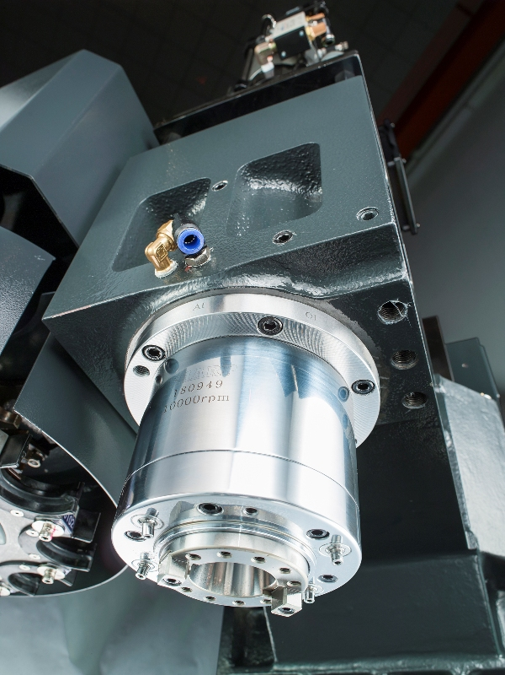 | Big Plus® spindle offers simultaneous dual contact between the machine spindle face and toolholder flange face, as well as the machine spindle taper and long toolholder taper shank. That results in rigidity improvement due to the larger fit diameter. It also increases the ATC repeatability, prevents displacement in the Z-axis and eliminates fretting corrosion of the toolholder.  Air Blower Nozzle allows dry cutting operation
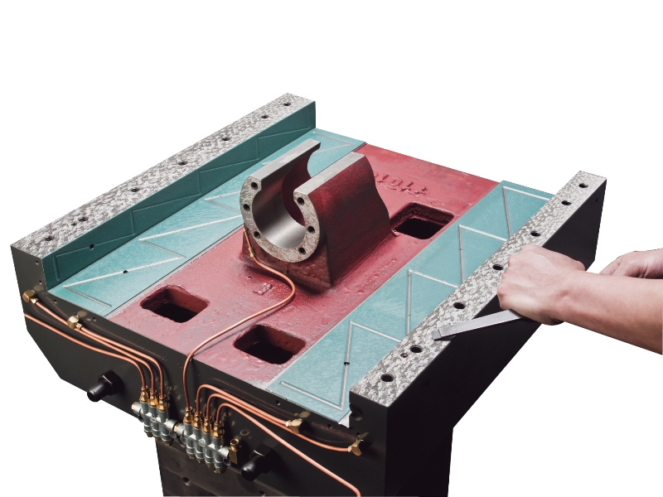 | Precision Hand Scraping  All mating surfaces are precision hand scraped to increase the flatness and improve geometric accuracy (straightness and squareness) of the whole assembly  Scraping the base casting where the column mounts is shown
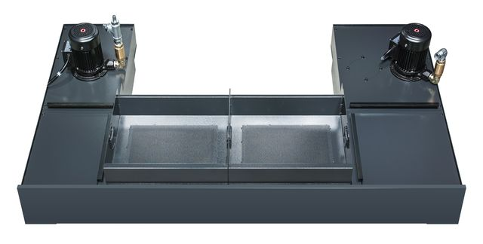 | Separate Roll Out Coolant Tank  A large separate roll out coolant tank is used to prevent heat in the coolant from transferring to the machine base casting.  63 gallon capacity  Coolant tank with standard chip bin is shown
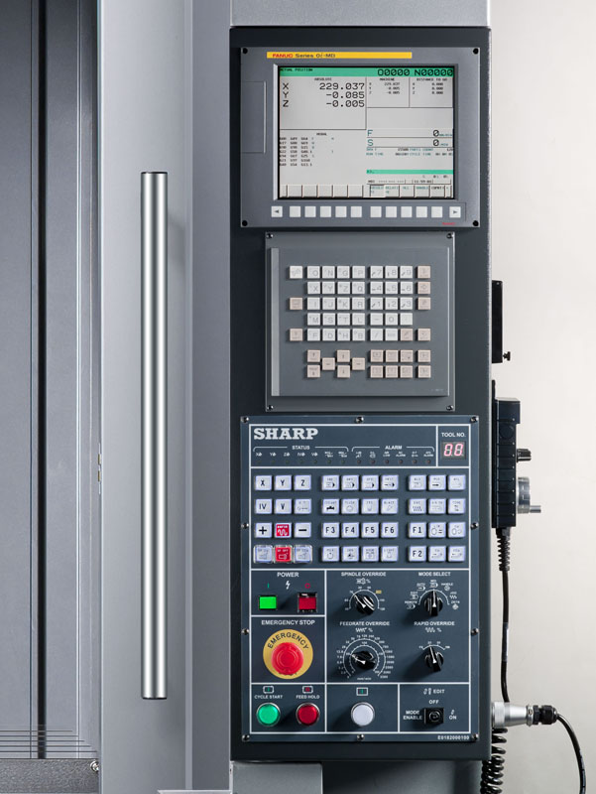 | Fanuc 0i-MD CNC Control  The new Fanuc 0i-MD CNC control comes with a 10.4”color LCD, a new user interface, more memory, 40 block high speed look ahead function, a faster processor and NANO interpolation. USB, RS232 port and Ethernet are also included
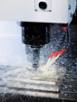 | Flood Coolant  High pressure flood coolant with adjustable nozzles is standard
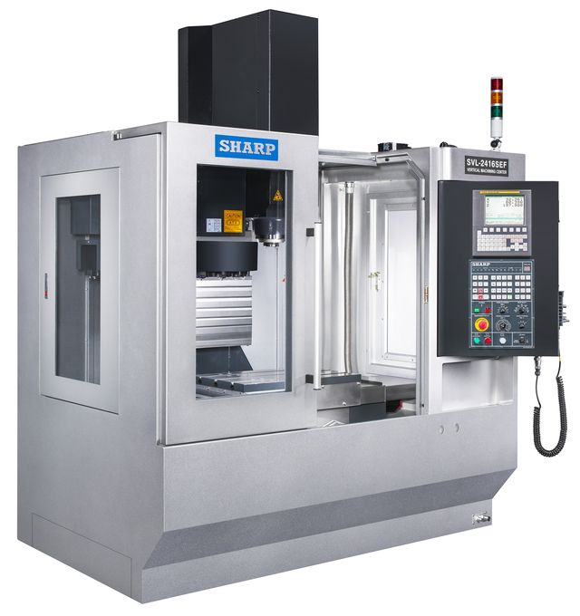 | Large Side Doors  Both sides of the machine enclosure have large removable doors. Long workpieces can be loaded through the sides. The door openings are large enough to allow full “Y” axis travel with long workpieces extending through the sides
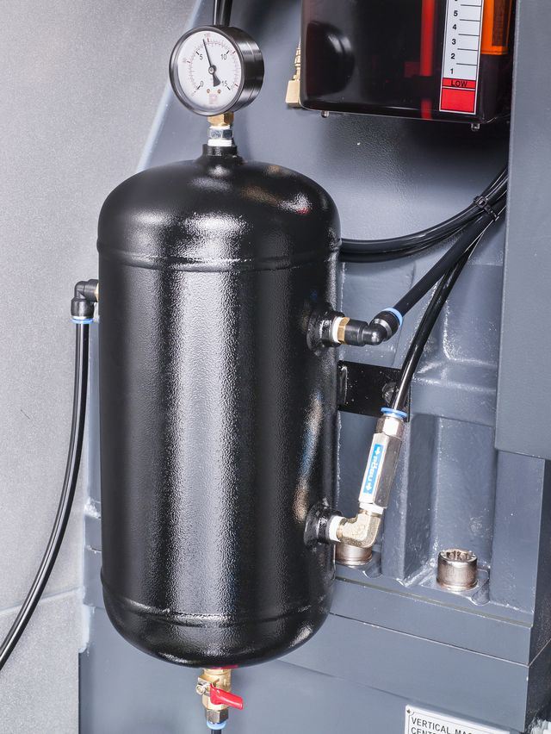 | Air Reservoir Tank  An air reservoir tank with alarm is used to stabilize the incoming air pressure and volume.  Automatic Lubrication System  Automatic lubrication with alarm is provided to all ways and ball screws. Lubrication oil is delivered by metered piston distributors to precisely control the volume of oil.
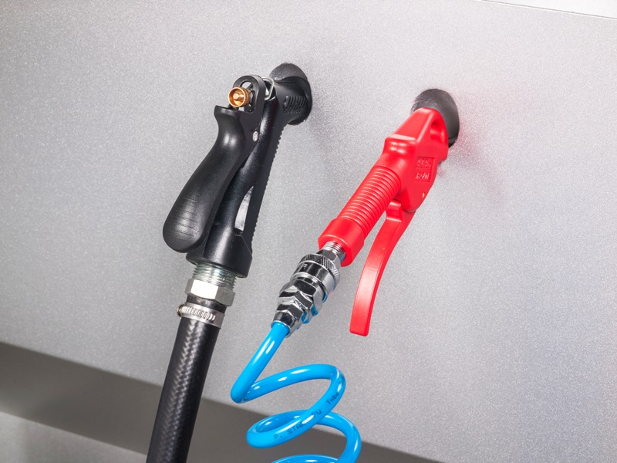 | Air Gun and Coolant Gun are conveniently located below the control panel . They are provided for blowing away chips embedded inside work piece holes and pockets as well as washing away chips piling up along the sides of the table.

Standard Accessories
Boxway Construction  CNC Control:  Fanuc 0i-MD  Spindle:  - Big plus CAT-40 taper  - 12,000 rpm  - Rigid tapping  - Spindle chiller  - Air blow (for cutting dry)  Automatic Tool Changer:  - 30 tools, arm type  - Air blast at tool change  Coolant System:  - 63 gallon roll out coolant tank  - Flood coolant system | - Auto-Lubrication System with Alarm  - Coolant gun  - Air gun  - Heat Exchanger for Electric Cabinet  - Fluorescent Work Light  - Air Reservoir Tank with Alarm  - 3 Tier Status Light  - Full metal enclosure with 2 large side doors  - Chip bin  - Oil skimmer  - Spindle oil chiller  .Door Interlock  - Tool kit, Leveling bolts and pads

SVL-4020SX-F | Fanuc 0i-MD control |  | $ 92,990.00
General Notes: |  | Equipment, specifications and materials are subject to change until order is accepted by Sharp Industries. Pricing is valid for 30 days
Delivery: |  | If not in stock, delivery lead time will be verified by the factory after receipt of your written, firm purchase order.
F.O.B.: |  | Gardena, Ca. U.S.A.  Sharp Industries responsibility ceases when delivery is made to the carrier. Any claim for loss and/or damages must be made by the purchaser against the carrier.
Terms: |  | Sharp Industries Standard Terms & Conditions will apply.  All factory special order machines require the following: End user purchase order to be issued to Sharp Industries as the Seller.  - 30 Per Cent (30%) down payment with your purchase order.  - 60 Per Cent (60%) prior to shipment.  - 10 Per Cent (10%) balance due net 30 days after final acceptance.
Warranty: |  | Special Sharp Industries 2 years’ Limited Warranty will apply.

Prices and specifications subject to change without notice

 | - Available Optional Accessories*
 | Machine Options
 | Flat belt chip conveyor for steel application |  |  | - $ 3190.00
 | Flat belt chip conveyor for aluminum application |  |  | - $ 3625.00
 | Riser block, 7.87” |  |  | - $ 1620.00
 | CTS 70 bar prepped ( factory order only) |  |  | - $ 1850.00
 | CooolJet T8-300 P, 300 psi cooling system for either 8 or 20 GPM with 40 G tank installed at Sharp |  |  | - $ 7,140.00
 | Chip Blaster J-30, 1000 psi cooling system for 8 GPM with 100 G tank installed at Sharp |  |  | - $ 12,500.00
 | CTS Pump ( CHIP BLASTER JV-40), 2-10.5 gpm @ up to 1,000 psi,vari volume ( factory installed) |  |  | $ 17,755.00
 | Tooling certificate from Iscar Metals. Certificate will be sent to end user directly from Iscar Metals. |  |  | $ 1000 and up
 | Fanuc AICC II (200 blocks look ahead) & installation at Sharp warehouse |  |  | - $ 1,950.00
 | Nano smoothing |  |  | - $ 1250.00
 | Bell-type acceleration/deceleration |  |  | - $ 250.00
 | 2 M memory expansion |  |  | - $ 1500.00
 | 2 G data server with Ethernet |  |  | - $ 4800.00
 | Installation charge of Fanuc s/w could be varied from $ 450 to $ 750 plus travel expenses if Fanuc does not have a local service center. |  |  | - pls call
 | 4 th axis prepped ( wiring only, no drive and no motor. factory order only) |  |  | - $ 1200.00
 | Fanuc 31i control in lieu of OIMD control with 3-axis linear guide scale |  |  | - $ 40,543.00
 | CE Mark ( factory order only) |  |  | - $ 6400.00
 | Rotary Table Options**
- Tsudakoma 6” Indexer: Model RZ-160 with TPC-Jr Controller  - 0.001 deg command unit. Includes cables, AC servo motor. ( no installation) |  |  | $ 13,900.00
- Tsudakoma 7.9” Indexer: Model RZ-201 with TPC-Jr Controller  - 0.001 deg command unit. Includes cables, AC servo motor. ( no installation) |  |  | $ 16,000.00
- Tsudakoma 6” rotary table: Model RNE-160R with Fanuc motor, amplifier, cables but no installation) |  |  | $ 15,600.00
- Tsudakoma 7.9 rotary table: Model RNE-200 R with Fanuc motor, amplifier, cables but no installation) |  |  | $ 20,700.00
- Nikken 7” rotary table: Model CNC-180-A-M with Fanuc motor, amplifier, cables but no installation) |  |  | $ 23,850.00
- Nikken 8” rotary table: Model CNC-202-A-M with Fanuc motor, amplifier, cables but no installation) |  |  | $ 26,250.00
- Factory installation of 4th axes rotary table |  |  | Net $ 2500.00

Prices and specifications subject to change without notice
30 % deposit is required and payment terms subject to Sharp standard terms and conditions.

Sharp Industries Inc. Limited Warranty
Sharp Industries warrants to the original purchaser, other than a purchaser for resale, (the “Purchaser”) that Sharp Industries machine tools shall be free of defects in materials and workmanship. For a period of one (1) year from completion of installation, or for a period of fifteen (15) months from date of shipment, whichever is earlier, Sharp Industries will, at its sole and exclusive discretion, either replace or repair any machine or part thereof defective in workmanship or material, at no charge to the Purchaser.
All warranty repairs must either be performed by or authorized by a Sharp Industries Authorized Service Organization. To obtain warranty service, Purchaser must contact their local Sharp Industries Authorized Service Organization. Purchaser must provide verification of the date of delivery/installation when requesting warranty service (dated installation report). Ground freight charges (UPS regular or common carrier truck) for all warranty replacement parts are paid by Sharp Industries. If machine is not operational, Sharp Industries will pay next-day air shipment charges for necessary parts weighing 100 lbs. or less. Materials or parts alleged to be defective shall be returned to Sharp Industries, at Sharp Industries’ request, transportation charges prepaid. After the warranty repair or replacement of a defective part, Sharp Industries’ warranty for such part shall continue for ninety (90) days or for the remainder of the original Limited Warranty, whichever is longer.
WARRANTY LIMITATIONS
This warranty shall remain in effect only if the machine is used and maintained in accordance with all operating and maintenance instructions set forth in the manuals and instruction sheets furnished by Sharp Industries. Sharp Industries shall have no liability to repair or replace defective parts until the Purchaser has fulfilled its payment obligations. No allowance will be made for repairs or alterations made without Sharp Industries’ prior written consent or approval. The limited warranty provided by Sharp Industries excludes the following:
- Damage, malfunction, or failure caused by or resulting from improper maintenance, misuse, neglect, accident or any other cause beyond the control of the Sharp Industries.
- Damage, malfunction, or failure caused by modification of the machine (mechanical or electrical) without written authorization by Sharp Industries.
- Damage, malfunction or failure caused by installation or use of accessories or peripherals not purchased through or authorized in writing by Sharp Industries.
- Paint, batteries, filters, fluids, fuses, light bulbs, or any commonly expendable item.
- Damage to machines and/or components while being transported from Sharp Industries’ warehouse or facility to destination.
- Accessories or peripherals not manufactured by Sharp Industries, which shall be subject only to whatever warranty that is supplied by the manufacturer of such product.
- CNC control, spindle and servo motors, spindle and servo drives, which are covered by a one (1) year manufacturer warranty.
No person, agent, distributor, dealer or company is authorized to change, modify or amend the terms of this Limited Warranty in any manner. Sharp Industries makes no warranties, guarantees or representations, express or implied with respect to the machine tool, or parts thereof, except to the extent such warranty is set forth herein. The equipment covered does not necessarily comply with any codes or standards unless specifically quoted, ordered, and so accepted.
THIS WARRANTY IS IN LIEU OF ALL OTHER WARRANTIES, EXPRESS OR IMPLIED, INCLUDING WITHOUT LIMITATION WARRANTIES OF MERCHANTABILITY OR FITNESS FOR ANY PARTICULAR USE OR PURPOSE. SHARP INDUSTRIES’ LIABILITY UNDER THIS WARRANTY IS EXPRESSLY LIMITED TO ITS PROMISE TO REPAIR OR REPLACE THE DEFECTIVE GOODS. SHARP INDUSTRIES SHALL HAVE NO FURTHER LIABILITY IN CONTRACT OR NEGLIGENCE OR UNDER ANY OTHER THEORY OF LAW OR EQUITY FOR ANY DAMAGES, DIRECT OR INDIRECT, INCIDENTAL, SPECIAL OR CONSEQUENTIAL, OR ANY DELAY RESULTING FROM THE DEFECT.

