MAL MACHINE TOOLS, LLC
BRISTOL, CT., 06010

GMM-5KV VERTICAL KNEE TYPE MILL W/ 5 HP #40 VARI SPEED SPINDLE 10 X 54” TABLE, BIG KNEE – 16” CROSS TRAVEL
*******************************************************

Standard Features:

- ISO 9001 certified
- Meehanite Casting
- Turcite B coating on X/Y ways like CNC mills
- GMM-5KV: Mechanical variable speed from 70 - 4,300 rpm
- Heavy duty 5HP AC spindle motor, 3 phase
- Hardened & ground guideways
- Square ways on Y and Z axis
- Hardened & ground table and Ground table T-slots
- Precision ground ACME Leadscrews
- Chromed ground quill ( spindle )
- Chromed dials
- Adjustable ways
- Hand brake on mill head
- Tilting & rotating head
- Manual or automatic quill feeds 0.0015” , 0.003”, 0.006” per spindle revolution
- One shot lube system
- front and rear rubber chip guards, and (1) manual draw bar
- Tool box
- Power source 220V or 208V, 3 phase ( 440 V/ 460 V is optional )
- One year warranty for parts

“GMC” Manual Knee Type Mills Specifications:
 | GMM-5KV
Table Size  Table Load Capacity | 10” x 54”  800 LBS
X Axis Travel  X travel with power feed  Y Axis Travel  Z Axis Travel | 36”  33”  16-1/2”  16-1/2”
Spindle Taper Type | NT40
AC Spindle Motor , | 5 HP
spindle speeds | 70-4,300 rpm  Variable speeds
Quill ( Spindle ) diameter | 4-1/8”
Quill ( Spindle ) travel | 5”
Ram travel | 22-1/2”
Table T-slot size | 5/8” x 3 slots
Head Swivel, R/H , L/H | 90 degree
Net weight, LBS | 4,050 LBS

Standard Equipment:
- Coolant system with base tray
- Halogen work light
- “CE” standard electric control box
- control panel
- One shot lube
- Rubber way covers
- Tool box

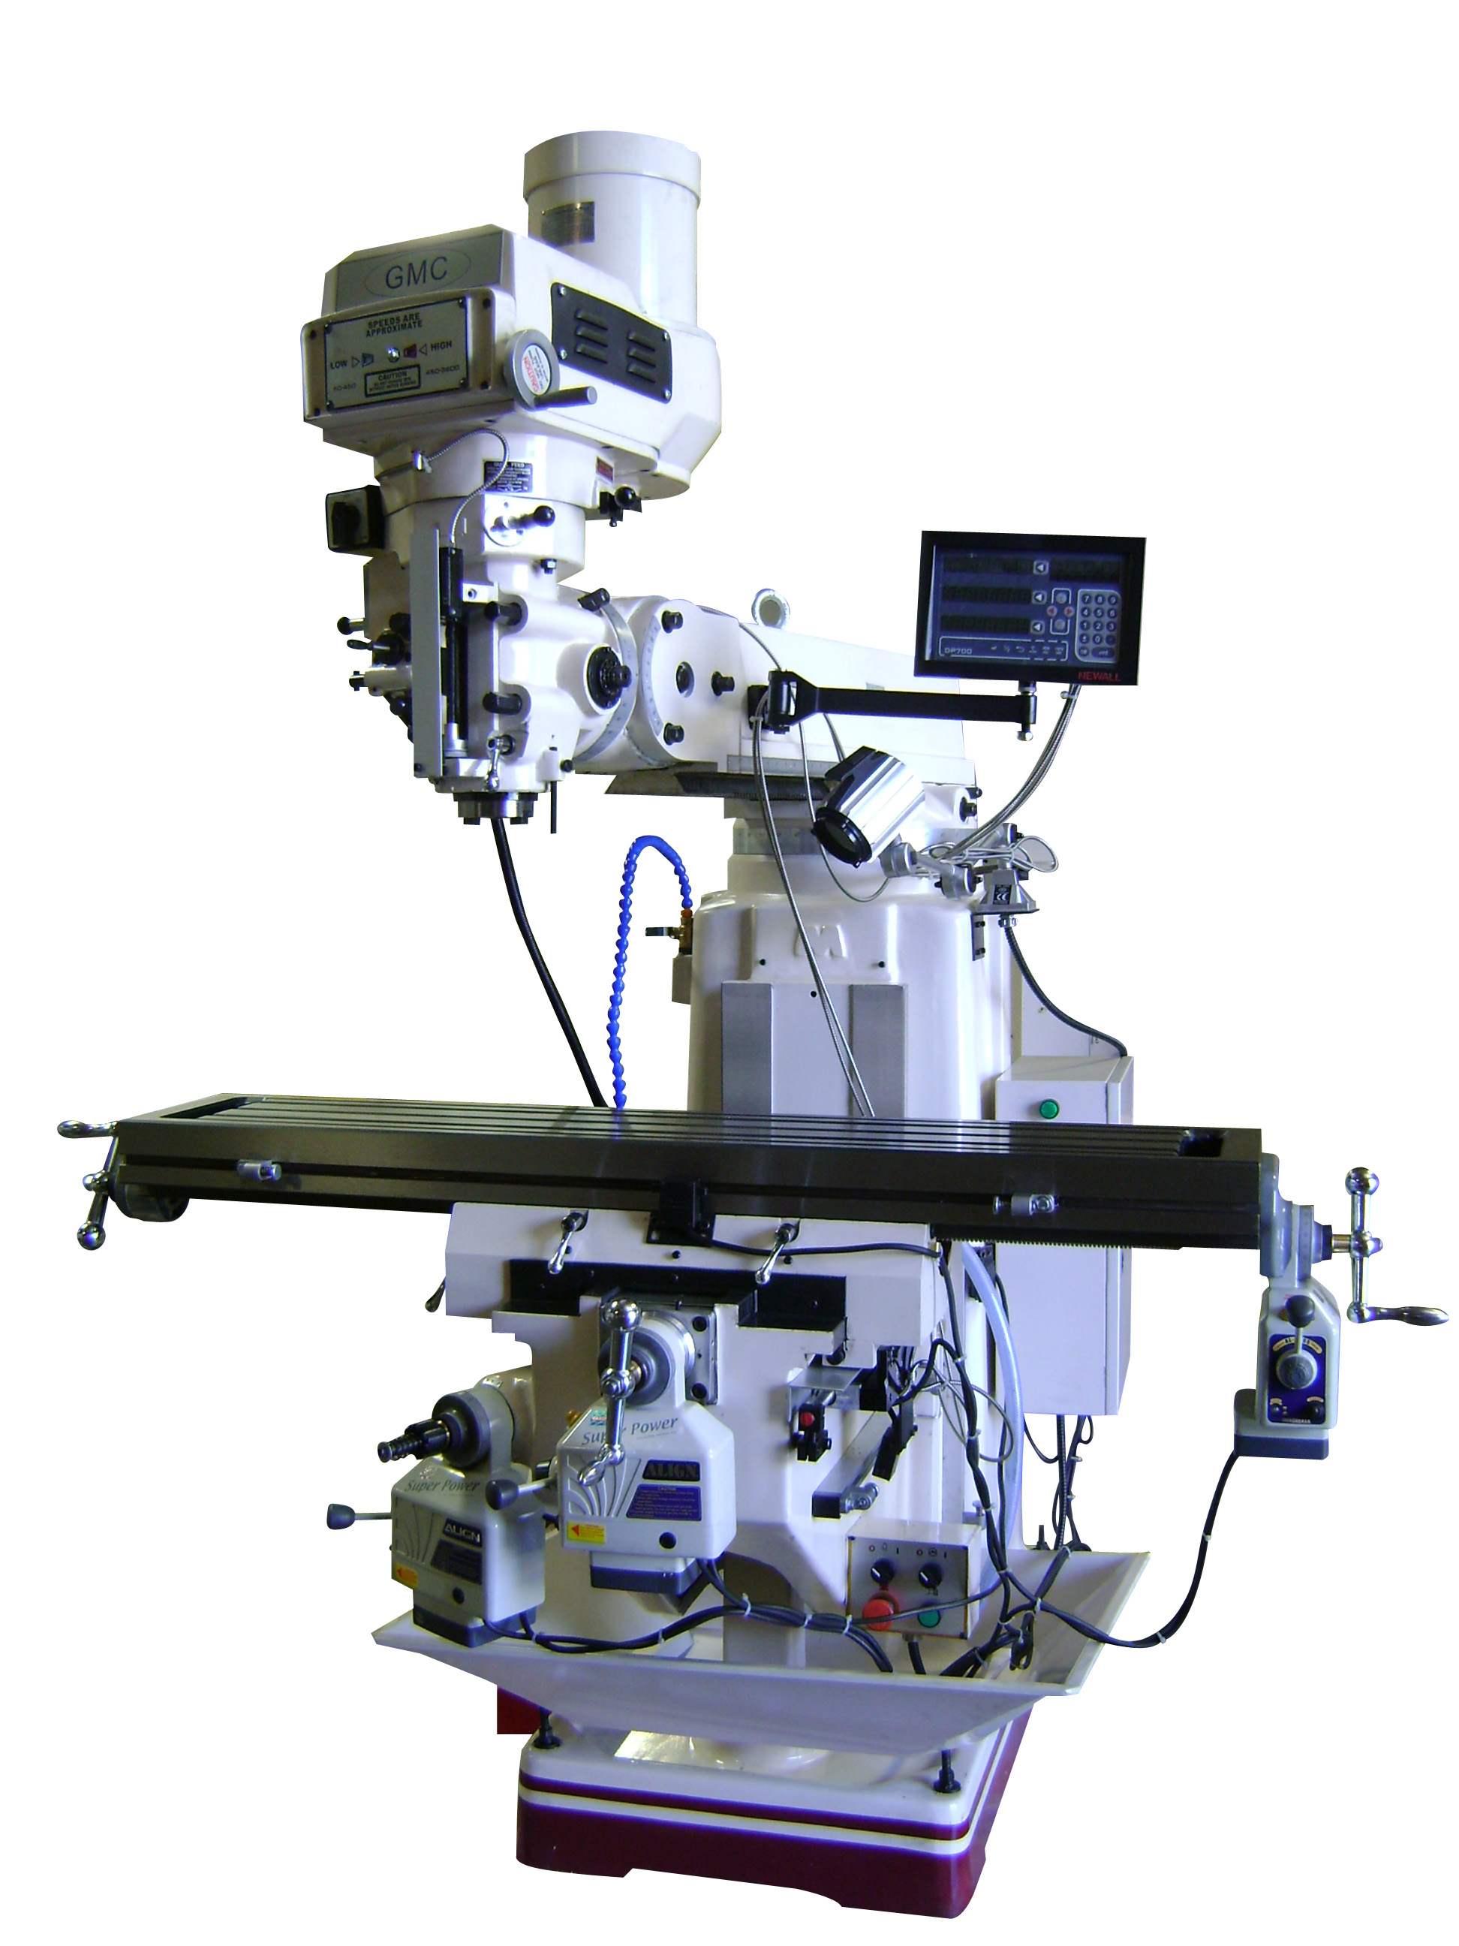 GMC GMM-5KV

