Sharp Precision Machine Tools
PROPOSAL

Bed Type CNC Mill

KMA-V1

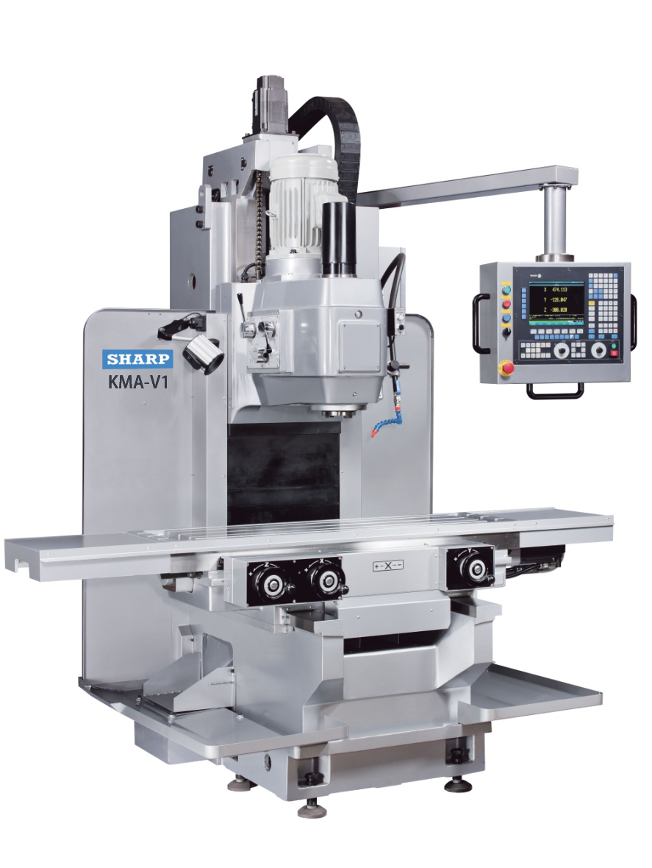

Heavy Duty Vertical Bed-Type Mill with Fagor 3- Axis CNC Control, KMA-V1 $ 80,880.00

STANDARD EQUIPMENT:

- Auto Lubrication System.
- All Gear 12 –step Cam Drive Continuous Speed
- X/Y/Z C5 Ball Screws
- 128 K Memory and Ethernet Interface
- Fagor 8055 i –Axis Control with 7.5” Color Monitor
- Digital Input/Output
- 75 Blocks Look Ahead
- Tool Kit with Manual.

SPECIFICATIONS:
- Capacity
- Table Travel (X) 39.4”
- Table Travel (Y) 15.7”
- Spindle Head Travel (Z) 19.7”
- Spindle Nose to Table Top 3.9 – 23.6”
- Spindle End To Column Front 18.7”
- Table
- Table Working Area 57” x 15.75”
- T-Slot (W x No. x Pitch) 18mm x 3mm x 100
- Table Top To Floor 37”
- Max Loading 1320 Lbs
- Spindle Head
- Spindle Nose NT No.50
- Spindle Speeds 45 to 1,600 RPM
- No. of Speeds 12 Steps
- Feeds(vertical) 4M/min
- Feeds
- Rapid Traverse (X,Y) X, Y: 6M/min; Z:4M/min
- Feeds (X,Y) 1~4000 mm/min for cutting
0~2M/min for jog
- No. of Feeds 61 Steps for jogging
- Motors
- For Spindle 10 HP
- X/Y/Z Speed X/Y: AC 0.8Kw; Z: AC 1.0Kw
- For Lubrication 200W x 4P
- For Coolant pump 100W x 2P
- Machine Size
- Machine Height 108.3”
- Floor Space (X,Y) 131.9” x 93.3”
- Net Weight (approx.) 9,680 LBS
- Standard Color Silver.
- Electrical:
- Voltage 220
- Amp 40A
- Phase 3

OPTIONAL ACCESSORIES:

Transformer

Factory Installation - PDB

Features, Function, & Benefits:
ISO 9002 certified factory:
Quality up to world industry standards.

Certified MEEHANITE Casting:
Highest grade of casting possible.

Hardened and Ground Gears
The gearbox inside the spindle head and the table feed mechanism utilize hardened and ground gears for long lasting wear. The spindle head gearbox is equipped with an automatic lubrication system. The table feed gearbox has an oil splash system for lubrication.

Pendant Style Operation Panel
The pendant control panel allows easy operation of all power driven mechanism, electrical, pneumatic or hydraulic. It has a toggle style control for 4-way feed and rapid traverse of the table.

Auto Lube Table and Saddle Ways
The slideways upon which the saddle and table travel, are automatically lubricated when the machine is turned on.

Hardened and Ground Boxways:
The C frame construction offers the best machining capability for heavy milling and boring applications. By using hardened and ground double box ways in the Z axis, significant rigidity is given to the cutting head. The saddle is also mounted on two massive hardened and ground body ways for maximum stability during heavy cutting.

Honey Combed Ribbing:
The vertical column is made out of box-shaped, high quality, gray iron castings. It is reinforced with honeycombed ribbing, instead of the usual rectangular ribbing, which is 70% more effective in dampening vibration and sustaining mechanical and thermal stability.

Table and Saddle:
High quality castings used on the table and saddle are stressed relieved to avoid any slight distortion in the future and the sliding surfaces are hand scraped to ensure full bearing support and to achieve high accuracy in machining. All top, front, rear reference surfaces and T slots are precision ground to exact tolerances.

Eye Level vertical Head Control:
The large spindle head offers manual coarse and fine in addition to power feed for positioning of the head. Controls for these feeds together with spindle speeds and the head locking mechanism are all mounted at eye level on the spindle head casting. The tri-lever rotating manual rapid feeds mounted at the front allowing quick positioning of the head for machining.

WARRANTY

SII hereby warrants to the purchaser of this product that the products shall be free from defects in materials and workmanship for a period of (1) one-year from the date of purchase. SII shall be liable only for the workmanship during the period of the warranty. No freight cost is included in this warranty. Any damage to the product as a result of misuse, abuse, neglect, accident, improper installation or improper operation shall void this warranty.
Destruction or alteration of Serial Number repair or alteration outside an authorized service center shall also void this warranty.

SII sells this product without implied warranties of any type. Including an implied warranty of merchantability.
The purchaser shall be solely responsible for determining the adequacy of the products for any and all uses to which the purchaser shall apply the product, and the application of the product by the purchaser to any purpose shall be subject to any implied warranties of fitness for that purpose.

Continued use or possession of the product after the period of warranty, the use and possession thereof during said period after the product has been repaired or serviced by SII, or the failure to give notice of any defects within (5) five days after they are discovered, shall result in the wavier of the breach of the warranty by the purchaser and the warranty shall be deemed to have been fulfilled.

SII is in no way responsible for consequential and incidental damages including any and all economic loss arising out of the use of our products. Seller shall not be liable for injury to property other than the goods themselves.

SII's obligation under the terms of this warranty are solely to the repair or replacement of the defective parts of our products, or at SII's option, refund of the purchase price. The determination of the liability of SII shall be solely within the discretion of SII after examination of the alleged defective part by an authorized agent of SII.

SII reserves the right to discontinue any model or change the specifications without notice. No discontinuance or change shall create any liability on the part of SII in respect to its products in the hands of its customers or products on order not incorporating such change even though delivered after such change.

SII and purchaser shall agree that any statements and representations made by SII were not a part of the basis of the bargain, and are not warranted to be accurate. SII and purchaser agree that if any statement made by purchaser in this agreement or otherwise is construed as an affirmation or promise it shall nevertheless not constitute a warranty that the goods will conform to the affirmation or promise.

