Sharp Precision Machine Tools
Proposal

PRECISION LATHE
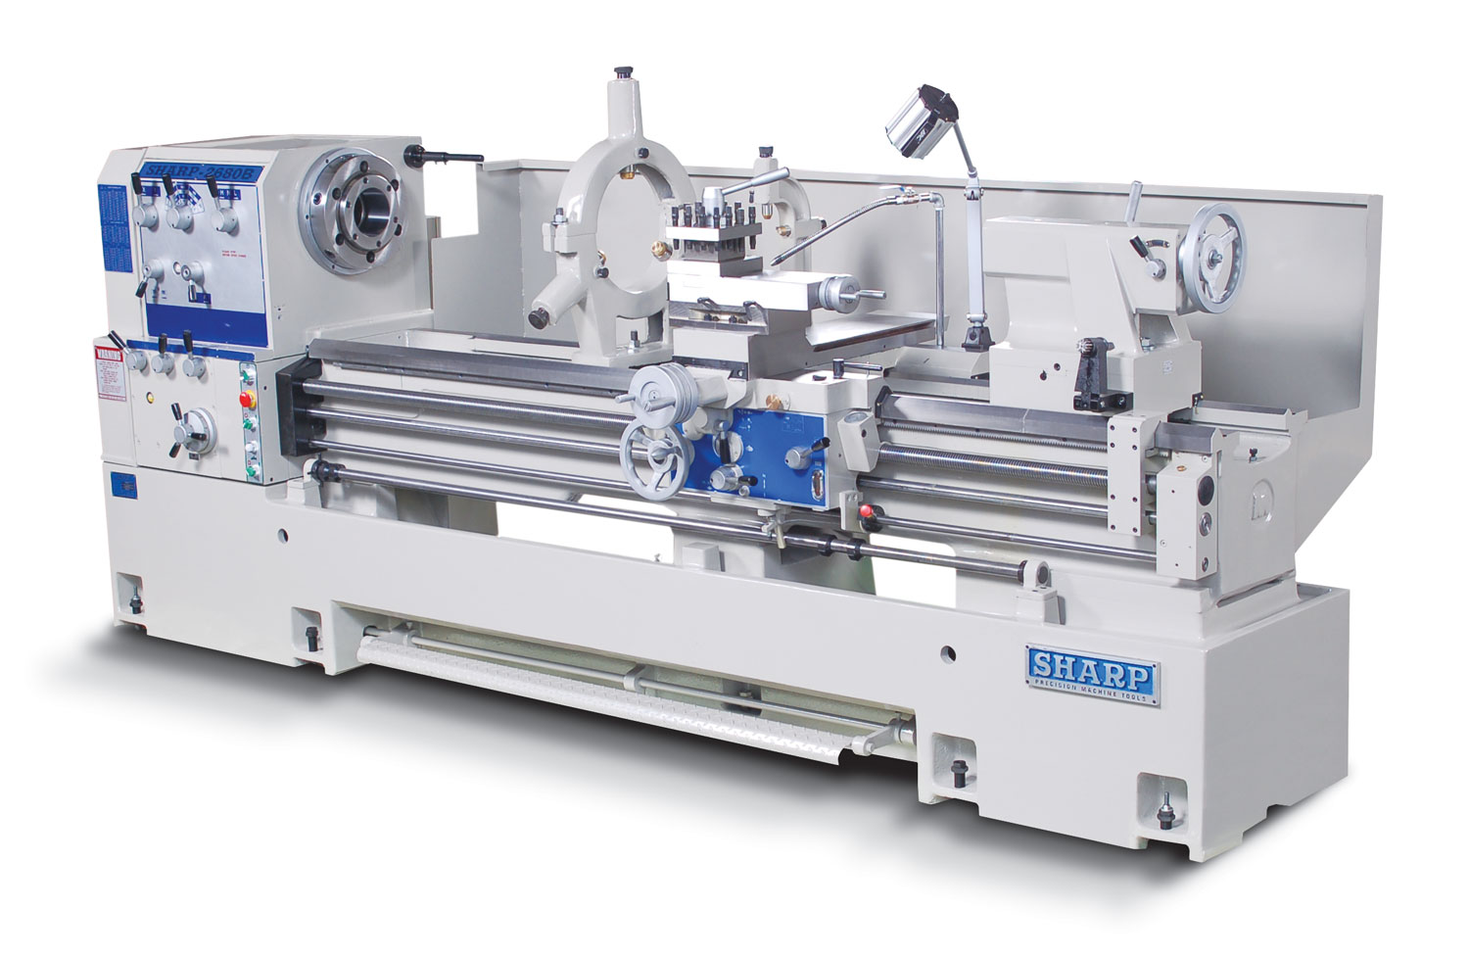

Picture: 2680B

26160B

Sharp 26160B Lathe: $47,630.00
(4.5” spindle bore)

STANDARD EQUIPMENT:
- Rapid Traverse on Longitudinal
- 4-Jaw Chuck 16”
- Coolant System
- Halogen Work Light
- Face Plate 20”
- Steady Rest (4”- 11.5”)
- 4 Way Tool Post
- 4 Way Carriage Stop
- Splash Guard
- 16” Chuck Guard
- Tailstock
- Follow Rest
- Tool Kit includes:
Machine Manual, Half Nut Wrench, Wrench 17m, 19m, Set of 6 Allen wrenches, Phillip Screw Driver, Flat Head Screw Driver, Oil can, Grease Gun, Rear Way Cover Bracket, Pin for Indicator, Can of Paint

FEATURES:
- D1-11 Camlock
- 4.5” Spindle Bore
- Direct Selection For Inch/Metric Threads
- One Piece Cast Meehanite Bed
- 15 Hp Spindle Motor
- 12-Speed Gear Head (10-1,000 RPM)

SPECIFICATIONS:
- Capacity
- Swing Over Bed 26”
- Swing Over Cross Slide 17- 1/ 3”
- Center Height 13”
- Swing Over Gap 35”
- Distance Between Centers 160”
- Headstock
- Spindle Nose Type D1-11 camlock
- Spindle Bore 4.5”
- Spindle Speeds (12) 10-1,000 rpm
- Taper of Spindle Bore MT#7
- Taper of Center MT#5
- Threads and Feeds
- Longitudinal Feeds – in/rev (18) 0.002 - 0.032”
- Cross Feeds – in / rev {#} 0.001 –0.0094” {17}
- Inch Threads (#) 2-56 tpi {44}
- Metric and Module Threads {#} 0.5-14mm {24}
- D.P. Threads (36) 4-56 mm
- Leadscrew Pitch, Diameter 4 tpi, 1-1/2”
- Carriage
- Cross Slide Travel 14.75”
- Compound Rest Travel 8”
- Compound Width 6”
- Bed
- Bed Length 183”
- Bed Width 15-3/4”
- Tailstock
- Quill Travel (graduated) 6-1/2”
- Quill Diameter 3”
- Quill Taper MT#5
- General
- Spindle Motor (220V or 440V, 60, 3) 15 hp
- Dimensions ( L x W x H) 218.5” x 40.5” x 51.6”
- Net Weight (approx.) 10,802 LBS
- Standard Color Gray
- Specifications may be changed or improved without notice.

Electrical:
- Voltage 230 & 460
- Phase 3 phase

- Total Power Consumptions
- 230V 16KVA/45 amps
- 460V 16VA/22.5 amps

OPTIONAL ACCESSORIES:
- 3 - Jaw Chuck 12” D1-11 (Bison) - 4.05” Bore 803-1239 $ 2,380.00
- 3 - Jaw Chuck 16” D1-11 (Bison) - 5.34” Bore 803-1639 $ 4,280.00
- 3 - Jaw Chuck 20” D1-11 (Bison) - 7.48” Bore 803-2039 $ 8,900.00
- 3 - Jaw Chuck 25” D1-11 (Bison) - 7.60” Bore 803-2539 $12,095.00
- 4 - Jaw Chuck 16” D1-11 (Bison) 853-1639 $ 1,835.00
- 4 - Jaw Chuck 20” D1-11 (Bison) 853-2039 $ 3,080.00
- 4 - Jaw Chuck 25” D1-11 (Bison) 853-2539 $ 4,180.00
- 3 - Jaw Chuck 15” D1-11 (BTC) 3J15D11 $ 1,500.00
- 3 - Jaw Chuck 20” D1-11 (BTC) 3J20D11 $ 3,550.00
- 4 - Jaw Chuck 16” D1-11 (BTC) 4J16D11 $ 1,580.00
- 4 - Jaw Chuck 20” D1-11 (BTC) 4J20D11 $ 3,395.00
- 4 - Jaw Chuck 25” D1-11 (BTC) 4J25D11 $ 3,695.00
- Taper Attachment (Factory Installed) 991126 $ 1,945.00
- Drill & Arbor (JACOBS) 22/30B-D/A $ 675.00
- Quick Change Tool Holder (Aloris) 7 pcs. CA-2511-7350 $ 2,020.00
- Live Center – Royal (Dual Bearing) MT#5 10855 $ 280.00
- Live Center – MT#5 LC-MT5 $ 150.00
- 5C Lever Collet Closer CC-2680B $ 1,500.00
Factory Installation - 5C Collet Closer $ 75.00 NET
- 5C Collet Set (1/8 to 1/16” x 1/16”) 16 pcs. ACC-5C $ 295.00
- Micrometer Carriage Stop 20C-02 $ 250.00
- Steady Rest 15” 26C-STEADY15 $ 2,310.00
- Steady Rest 19.5” 26C-STEADY 20 $ 2,950.00
- Roller Jaws Set (3 pcs) 26C-RJAW $ 630.00
- UL/CSA switch board/UL motor/CSA pump in lieu of regular version( factory order)
UL/CAS 26120 $ 3010.00
NOTE: SHARP DOES NOT PROVIDE UL/CSA STICKERS ON THE MACHINES, BUYERS NEED TO CONTRACT A LOCAL AGENCY TO REVIEW THE ISSUES THEN PUT "COMPLIANCE" STICKERS ON THE MACHINES AFTERWARDS.
DIGITAL READ OUT SYSTEMS:
- Fagor 20i D.R.O. FG-26160 $ 5,575.00
- Fagor 40i D.R.O. FG-40i-26160 $ 6,160.10
- Acu-Rite 200S D.R.O. AR-26160 $ 9,360.00
- Newall DP700 D.R.O. NWDP-26160 $ 5,490.00
Factory Installation - D.R.O. $ 525.00 NET

Note: All prices and specification subject to change without notice. Please verify

WARRANTY

SII hereby warrants to the purchaser of this product that the products shall be free from defects in
materials and workmanship for a period of (1) one-year from the date of purchase. SII shall be liable only for the workmanship during the period of the warranty. No freight cost is included in this warranty. Any damage to the product as a result of misuse, abuse, neglect, accident, improper installation or improper operation shall void this warranty.
Destruction or alteration of Serial Number repair or alteration outside an authorized service center shall also void this warranty.

SII sells this product without implied warranties of any type. Including an implied warranty of merchantability.

The purchaser shall be solely responsible for determining the adequacy of the products for any and all uses to which the purchaser shall apply the product, and the application of the product by the purchaser to any purpose shall be subject to any implied warranties of fitness for that purpose.

Continued use or possession of the product after the period of warranty, the use and possession thereof during said period after the product has been repaired or serviced by SII, or the failure to give notice of any defects within (5) five days after they are discovered, shall result in the wavier of the breach of the warranty by the purchaser and the warranty shall be deemed to have been fulfilled.

SII is in no way responsible for consequential and incidental damages including any and all economic loss arising out of the use of our products. Seller shall not be liable for injury to property other than the goods themselves.

SII's obligation under the terms of this warranty are solely to the repair or replacement of the defective parts of our products, or at SII's option, refund of the purchase price. The determination of the liability of SII shall be solely within the discretion of SII after examination of the alleged defective part by an authorized agent of SII.

SII reserves the right to discontinue any model or change the specifications without notice. No discontinuance or change shall create any liability on the part of SII in respect to its products in the hands of its customers or products on order not incorporating such change even though delivered after such change.

SII and purchaser shall agree that any statements and representations made by SII were not a part of the basis of the bargain, and are not warranted to be accurate. SII and purchaser agree that if any statement made by purchaser in this agreement or otherwise is construed as an affirmation or promise it shall nevertheless not constitute a warranty that the goods will conform to the affirmation or promise.

